

Melkbosstrand High School
Grade 11 | Computer Applications Technology |  | Term 3  26 August 2026
Time: 1 hour | Task 4  Practical |  | Marks: 50
Examiner: F. Pretorius |  | Moderator: R. Rabe
INSTRUCTIONS AND INFORMATION
- During the examination, normal rules regarding leaving the examination room apply.

- Ensure that you save each document using the file name given in the question paper. Save your work at regular intervals as a precaution against possible power failures.

- Read through each question before answering or solving the problem. Do NOT do more than is required by the question.

- Unless instructed otherwise, use formulae and/or functions for ALL calculations in questions involving spreadsheets. Use absolute cell references only where necessary to ensure that formulae are correct when you copy them to other cells in a spreadsheet.

- The examination folder that you receive with this question paper will contains the files listed below. Ensure that you have all the files before you begin this examination.

QUESTION 1: WORD-PROCESSING
SCENARIO: DIAMONDS – Keep calm and sparkle.
Diamond Insights, a cutting-edge diamond company, is embracing 5IR technologies to transform diamond mining, improve safety and enhance productivity.

Open the 1Diamonds word-processing document.
1.1 | Convert the footnote created in the first paragraph to an endnote and ensure that it appears as follow:  NOTE:  Use Webdings character 126 () as the endnote symbol. | (2)
1.2 | Create a new style named ‘Subheading’, based on the Heading 2 style with the following specifications:  - Font colour dark blue, size 12 pts.. | (4)
1.3 | Add the following source to the document:  - De Beers Group. (2025). Annual Report 2025. Retrieved from https://www.debeersgroup.com on 15th February 2026.  Convert the existing ‘Resources’ section to a Bibliography to include the above source. | (3)
1.4 | Insert an automatic table of contents (TOC) of your choice above the ‘Introduction’ to display 2 level of sub-headings. | (3)
Save and close the 1Diamonds word-processing document.
 |  | [12]

QUESTION 2: SPREADSHEETS
_{NOTE:}
- Use formulae and/or functions for ALL calculations in the spreadsheet.
- Use absolute cell references ONLY where it is required by the question to ensure that formulae are correct when you copy it to other cells in the spreadsheet.
- Insert formulae and/or functions in such a manner that the correct results will still be obtained even if the existing data changes.
- Should you need to use building blocks, use the allocated space in the spreadsheet.

Open the 2Diamonds Data spreadsheet, which contains information about various diamonds that have been mined, as well as details of the investors associated with them.
Work in the Investors sheet
2.1 | Apply an appropriate number format to Price per Carat column. | (1)
2.2 | Apply conditional formatting to the Colour Code column to highlight in green all the cells with an ‘F’ as code. | (3)
2.3 | Add a Freeze pane to the investors sheet ensure that the headings and the 3 columns on the left will not move when scrolling. | (2)
2.4 | In the Summary sheet in cell b2 add the total of the Base Price from the Investors’ sheet. | (3)
2.5 | Change the investors sheet as follows when printing this sheet.
 | - ensure that only the cells A1 to K101 will be printed.  - the heading at the should repeat on each page  - and set the page to landscape and make sure that all columns will display on one page.  - Print the document to a pdf and name the document Investors. | (6)
Save and close the 2Diamonds Data spreadsheet.
 |  | [15]

QUESTION 3: DATABASE
Diamond Insights (Pty) Ltd stores information about diamonds, customers and sales in a database. The database has been created but requires improvements to ensure that data is captured accurately and reports can be generated efficiently.
Open the 3Diamond Sales database.
3.1 | Open the tblDiamonds table in Design View and make the following changes:
 | 3.1.1 | Change the DiamondID field so that:  - Field Size = 6  - Required = Yes | (2)
 | 3.1.2 | Apply an Input Mask to the DiamondID field so that the code is entered as:  - Example: D1001  - 1 Required letter  - 4 Required numbers | (2)
 | 3.1.3 | Set the default value of StockStatus to ‘Sold’. | (1)
3.2 | Use the Report Wizard to create a report:
 | 3.2.1 | Containing the following fields, in this order:  - DiamondID, Carat, CutCode, ColourCode, ClarityCode, PriceZAR and StockStatus. | (2)
 | 3.2.2 | Group the records according to the StockStatus field. | (1)
 | 3.2.3 | Sort the records within each group in ascending order according to DiamondID. | (2)
 | 3.2.4 | Select a suitable tabular layout and set the page orientation to Landscape. | (2)
 | 3.2.5 | Save the report as rptDiamondSummary. | (1)
3.3 | Apply the following formatting to the report:
 | 3.3.1 | Change the report heading to:  DIAMOND STOCK AND VALUE SUMMARY | (1)
 | 3.3.2 | Ensure that the complete contents of all fields and labels are clearly visible without unnecessary blank spaces | (1)
 |  |  | [15]

QUESTION 4: WEB DESIGN (HTML)
NOTE:
- You may NOT use a word-processing program such as Word to answer the HTML questions.
- An HTML tag sheet has been attached for reference.
- All files needed to complete this question are found in the examination folder.

4.1 Open the incomplete 4Diamonds Insights.html file in a web browser and in a text/HTML editor.
- Question numbers appear as comments in the coding to guide you where to insert the answer(s). DO NOT delete these comments.
- Your final page should look like the example below.
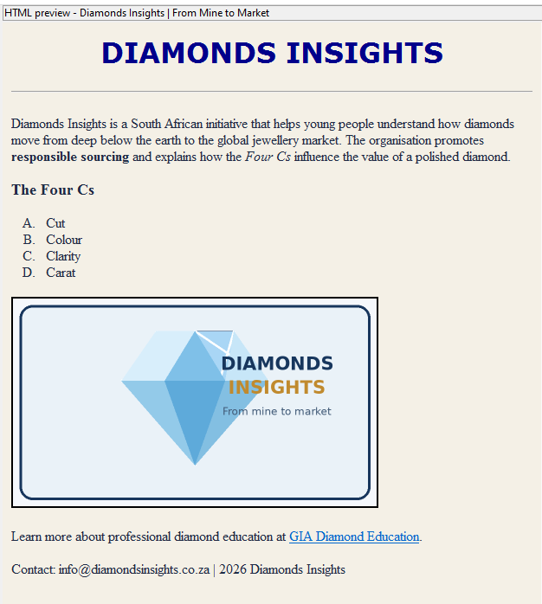
Diamonds Insights is creating an educational webpage that explains the journey of a diamond from mine to market. You have been asked to improve the supplied webpage so that it is accurate, attractive and easy to navigate.
- Use the supplied diamond_insights.png image. Keep it in the same folder as the HTML file.
4.1.1 | Set the webpage background colour to #F4F0E6 | (1)
4.1.2 | Change the list under The Four Cs to an ordered list that uses capital letters (A, B, C …). | (2)
4.1.3 | Edit the diamond image so that it:  - Has the alternative text ‘Faceted diamond – Diamonds Insights’. | (2)
4.1.4 | Correct the diamond-education hyperlink so that it links to https://www.gia.edu/diamond-education and displays the text “GIA Diamond Education” on the webpage. | (2)
 | ONE mark will be allocated for the correct use of tags and triangular brackets. | (1)
 |  | [8]

GRAND TOTAL: 50 MARKS

